Lab 5 – Forces in Equilibrium [virtual]
Video link: https://www.youtube.com/watch?v=UrHywLhpHYI&list=PLLF2jNBy_OPumuv2eSvIbvnDDfQj0cGEU&index=4
Instructions
- Make sure the force table is level
- Measure OUTSIDE angles
- Include units on all entries
  - All entries must be in base SI units unless otherwise specified
- All entries must have the appropriate number of digits
- Show all calculations

Table 1: Precision limits of measuring instruments.
Angular uncertainty | 1 degree
Mass uncertainty | 1 g

Table 2: Applied vector forces.
 | Weight #1 | Weight #2 | Weight #3
Angle | $$220°$$ | $$169°$$ | $$67°$$
Mass | $$0.100 kg$$ | $$0.160 kg$$ | $$0.180 kg$$
Weight force | 1N | 1.6N | 1.8N

Table 3: Equilibrium force.
 | Weight #4
Angle | 321
Mass | 210 g
Force | 2.2N

If you complete the lab in-person, copy a photo here of your centered ring with the forces in equilibrium.

Question 1: Draw a free body diagram of your four forces, with a coordinate system and all forces labeled.
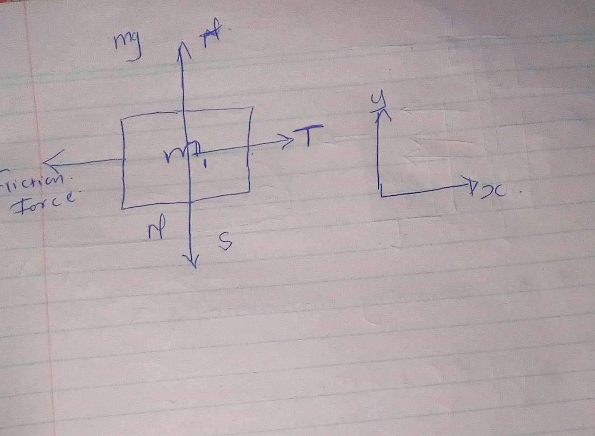

Question 2: Use the conditions of static equilibrium to derive the theoretical prediction. (System of equations – two equations and two unknowns)
$$\sum{\overset{⃑}{F}}=0$$
$${\overset{⃑}{F}}_{1}+{\overset{⃑}{F}}_{2}+{\overset{⃑}{F}}_{3}+{\overset{⃑}{F}}_{4}=0$$
$$\sum{{\overset{⃑}{F}}_{x}}=0$$  $${\overset{⃑}{F}}_{1x}+{\overset{⃑}{F}}_{2x}+{\overset{⃑}{F}}_{3x}+{\overset{⃑}{F}}_{3x}+{\overset{⃑}{F}}_{4x}=0$$  $$F_{1}\cos\left(θ_{1}\right)+F_{2}\cos\left(θ_{2}\right)+F_{3}\cos\left(θ_{3}\right)+F_{4}\cos\left(θ_{4}\right)=0$$ | $$\sum{{\overset{⃑}{F}}_{y}}=0$$  $${\overset{⃑}{F}}_{1y}+{\overset{⃑}{F}}_{2y}+{\overset{⃑}{F}}_{3y}+{\overset{⃑}{F}}_{4y}=0$$  $$F_{1}\sin\left(θ_{1}\right)+F_{2}\sin\left(θ_{2}\right)+F_{3}\sin\left(θ_{3}\right)+F_{4}\sin\left(θ_{4}\right)=0$$

Equation 1: Horizontal static equilbrium
$$(0.980 N)\cos\left(220°\right)+(1.57 N)\cos\left(169°\right)+(1.76 N)\cos\left(67°\right)+F_{4}\cos\left(θ_{4}\right)=0$$

Equation 2: Vertical static equilibrium
$$(0.980 N)\sin\left(220°\right)+(1.57 N)\sin\left(169°\right)+(1.76 N)\sin\left(67°\right)+F_{4}\sin\left(θ_{4}\right)=0$$

Trig identity
$$\tan\left(θ_{4}\right)=\frac{\sin\left(θ_{4}\right)}{\cos\left(θ_{4}\right)}$$
According to newton’s second law of motion
$$submission of vector of force=MaCM$$
Here the sum of all external forces acting on the body where m is mass is =
$$vector of aCM$$
Where this is the acceralation of its Centre mass
First equilibrium condition

$$submision of force=to vector of zero$$
The first equilibrium condition, is the equilibrium condition for forces which are encountered when studying laws of newton.
This vector equation are equivalent to the following three scalar equations for component’s of net force.
Submission of F_{KX}=0 submission of F_{ky} =0 F_{KZ=}0
ANAGOUSLY we can state that rotational acceleration= vector ofα of a rigid body about a fixed axis of rotation caused by the net torque acting on the body
Submission of vector T_{K}=Iα
Here the rotational inertia of the body in rotation about the axis and summation of all torques
Vector of T_{K}
For second and third conditions
F_{1x}+f_{2x}+f_{Nx}=0
F_{1Y}+F_{2Y}+F_{NY}=0
Where the summation is over all N external forces acting over the body and the torques.

Back to our equation
$$\tan\left(θ_{4}\right)=\frac{\sin\left(θ_{4}\right)}{\cos\left(θ_{4}\right)}$$
=$tan=\frac{sin324}{cos324}=-0.727degrees$
Torque 1=1*-0.727=-0.727
Torque 2=1.6*-0.727=-1.1536
Torque 3=1.8*-0.727=-1.3086
Torque 4=2.2*-0.727=-1.5994
-0.727+-1.1536+-1.3086+-1.5994=-4.79
Resultant force=4.79N±1, THIS IS THE EXPERIMENTAL FORCE
Table 4: Percent difference. Answer in units of percent.
 | Force magnitude | Theta
Percent difference | $$1\%$$ | $$0.3\%$$

$$\% \text{difference}=\frac{\text{(Experimental result)-(Theoretical prediction)}}{\text{Theoretical prediction}}$$
1=4.79-X/X
X=4.79N WHICH IS TE THEORETICAL FORCE.

